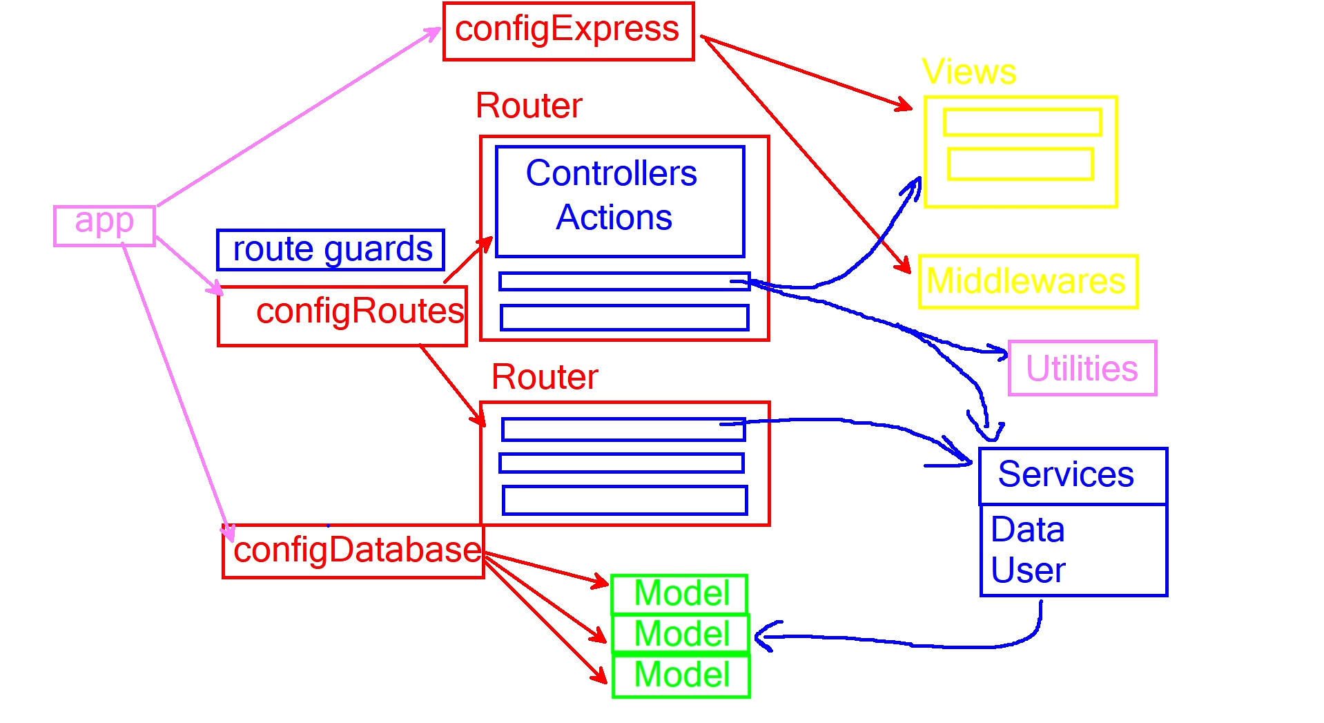

npm init -y

npm i express express-handlebars express-validator bcrypt mongoose jsonwebtoken cookie-parser
- save-dev nodemon

